Ildo Song

Bass

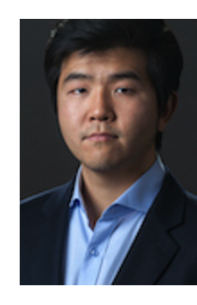
Young Korean bass Ildo Song gave 2022 his debut at the opera of Amsterdam in the part of the 5th Jew in Salome.

From 2017 to 2021 Ildo Song belonged to the ensemble of Zurich Opernhaus, where he sang Dottore Grenvil in La Traviata under Fabio Luisi, Eremit in Der Freischütz under Axel Kober, Julian Pinelli in Schreker’s Die Gezeichneten conducted by Vladimir Jurowski, Zio Bonzo in Madame Butterfly conducted by Fabio Luisi, Conte di Ceprano in Rigoletto conducted by Gustavo Gimeno, Alessio in La Sonnambula conducted by Maurizio Benini, Oroveso in Norma under Fabio Luisi, Erster Nazarener in Salome under Ulf Schirmer, Ambrogio in Il Barbiere di Siviglia under Enriche Mazzola, Commissario imperiale in Madame Butterfly under Daniele Rustioni, Sciarrone in Tosca under Paolo Carignani, La Voce in Idomeneo under Giovanni Antonini, Le Fauteuil/L’Arbre in L’enfant et les sortilèges, Mandarin in Turandot under Giampaolo Bisanti, La Voce in Idomeneo, and participated in both Orlando Paladino and Don Carlo.

He geusted at the Teatro San Carlo in Naples as Oroveso in Norma in 2020 and as Zio Bonzo in Madame Butterfly in 2019.

From 2015 to 2017 he was in the Opera Studio of Zurich Opernhaus, where he debuted as Antonio in a new production of Rossini’s Il Viaggio a Reims staged by Christoph Mathaler and conducted by Daniele Rustioni.

He has already appeared as Sarastro in Die Zauberflöte, as Sparafucil in Rigoletto, as Figaro in Le Nozze di Figaro, as Don Alfonso in Così fan tutte and as St. Peter in Too many sopranos at Seoul Kim Young Hee Hall, at Seoul National University Hall and at the Seoul Art Center.

In Locarno he sang very successfully for the first time Verdi’s Messa da Requiem conducted by Markus Poschner in fall 2018.

Ildo Song is an award winner at several Korean Voice competitions.
2014 he won 3rd prize at the International Hans Gabor Belvedere Competition in Düsseldorf.

08/2022

