Stéphanie Müther

Dramatic Soprano

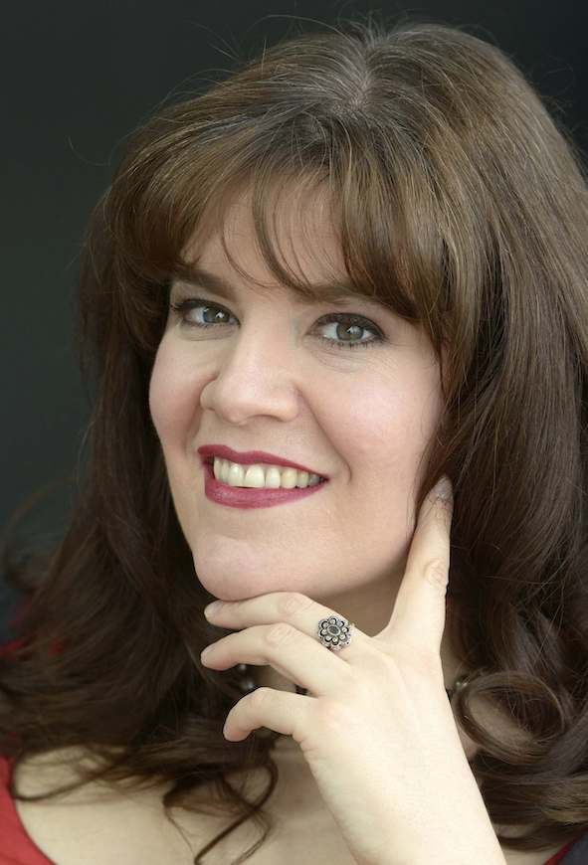
Plans of Stéphanie Müther include, among others, Brünnhilde in a new production Götterdämmerung as well as in complete Ring cycles directed by Peter Konwitschny in Dortmund. In Kyoto she will sing a Wagnerian concert, in Oviedo Ortrund in Lohengrin.

She started as Elvira in Verdi’s Ernani in Oviedo into the year 2023, followed by Ortrud in Lohengrin in both Chemnitz and Dortmund.
She gave her debut at the Bayreuth Festival 2022 as Waltraute in Die Walküre and 2nd Norn in Götterdämmerung as well as as Ortrud in Lohengrin in a version for children.

2019 she performed for the first time Brünnhilde in a complete Ring cycle in Chemnitz in 2019. From 2018 – 2020 she sang the same part conducted by Ryusuke Numajiri and directed by Michael Hampe at Biwako Hall in Tokyo. In Oviedo she was heard as Brünnhilde in Götterdämmerung.

She gave her debut as Ortrud in Lohengrin in Dortmund, little later she performed the same role in production by Joan A. Rechi Chemnitz. 2021 she gave her debut in the part of Isolde in a new production of Tristan und Isolde in Chemnitz.
And in Dortmund she gave her debuts in the title roles of Tosca and Turandot.

Stéphanie Müther began her career as a mezzo-soprano in roles like Herodias in Salome, Fioretta in Leoncavallo’s I Medici or Sesto in La Clemenza di Tito. 2016 she started into her soprano career with huge success in the part of Lady Macbeth in Verdi’s Macbeth in Erfurt.

She got a Colette-Mosetti scholarship in 2001 and a scholarship of the Richard Wagner-Verband Weimar for Bayreuth in 2013.
She has worked with stage directors such as Katharina Thalback Vera Nemirova and with conductors such as Claudio Abbado, Mariss Jansons, Charls Dutoit, Joana Mallwitz and Ulf Schirmer.
She holds a master degree of the Geneva conservatory, branch Neuchâtel, and was a member of the Swiss Opera studio in Biel.

Stéphanie Müther preparing new roles, like Isolde in Tristan und Isolde, the title role of Tosca, Elvira in Verdi’s Ernani or Färberin in Die Frau ohne Schatten and working on her actual repertoire together with Ion Buzea

07/2023

