Michael Gees

Pianist

Michael Gees’ biography is somewhat unusual: Who can say about himself to have had a career already at the age of 15? Michael Gees can. Born in 1953 in a musical family, both parents were singers, music was all around him. At the age of three the piano was his preferred toy; at the age of five he got his first piano lessons, at the age of eight he won the Steinway Competition and a scholarship of the Salzburg Mozarteum. He is praised as the „Westphalian Mozart“, he studies at the Music academies of Vienna and Detmold and it looks as if nothing could constrain him from becoming a famous pianist.
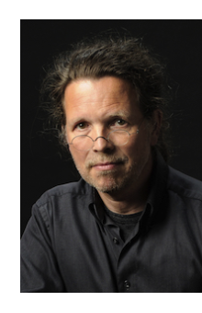
If there was not the desire of this talented child to explore the world of sounds in it’s own way, to re-invent it note by note instead of only practising technique. At the age of 15 Michael Gees escapes from the predetermined way, he leaves his home, family and musical studies behind him and earns his life by occasional jobs. He works as an archaeological helper and for two years as a mariner.

By accidence he gets to the Hochschule für Musik und Theater in Hannover, where he studies composition. He finds his own way of developing his accomplishment as a pianist, he composes, he builds up his reputation as a fine accompanist for singers and he give concerts all around the world. He is cultivating his preference to combine the music of the “old masters” with vivid inspiration and creates exceptional concerts.
1989 Michael Gees founds „forum kunstveint“ in Gelsenkirchen, where he lives; 2001 he opens in the area of the former coal-mine Consolidation the Consol Theater. In this theatre projects for music, dance and theatre are created, in which people of all generations are invited and encouraged to live their own creativity.

Michael Gees has recorded many CDs. His recording of Die schöne Müllerin with Christoph Prégardien received the MIDEM award and was appointed “recording of the year”. Lately he recorded Lieder zwischen Leben und Tod with Christoph Prégardien, ImproviSatie (piano music by Erik Satie with Extempores), Die Winterreise with Christoph Prégardien, Beyond Schumann (piano music by Robert Schumann mit Extempores) and Schöne Welt, wo bist du? with Julia Kleiter.
Since 2009 he teaches at the Musikhochschule in Cologne.

11/2022

